**Leader Overview**



**Volume Overview**

**Honor God**

*Most people think of worship as exclusively songs and music. We think worship is something we do in a service on Sunday mornings. But the Bible calls us to give our entire life as worship. We honor God with our songs and praise, but all of life is an opportunity to show God honor. We worship best when we make it a lifestyle, expressing our gratitude, prioritizing our time with Him, purifying our heart and actions, and generously sharing with others. We worship as we honor God with our whole life.*

**Session Overview**

**Live Generously**

*In this* **Live** *session, kids will discover that all our talents, time, and treasure are gifts from God. The Parable of the Talents shows kids that we should willingly give our gifts back to Him in any way possible. He wants us to use our gifts to further His mission and share His love with others.*

**Bible Lesson**

Parable of the Talents

[Matthew 25:14–30](https://ref.ly/logosref/Bible.Mt25.14-30)

**Faith Fact**

I will use my gifts for God.

**Faith Verse**

[Psalm 86:12](https://ref.ly/logosref/Bible.Ps86.12) (NLT)

With all my heart I will praise you, O Lord my God. I will give glory to your name forever.

**Preparing for the Session**

**Leader Preparation Time: 20–25 Minutes**

|  |
| --- |
| ***You Will Need***  ***Large Group***   * *Bible* * *Worship songs (Song suggestions: “Alive” Lyric Video by Hillsong Young & Free; “Make Room” Lyric Video by Community Music; “Great Are You Lord” by All Sons and Daughters; “Only King Forever” Lyrics Video by Elevation Worship)* * *For groups not using a phone or tablet only, add:*   *• Projector or TV*  *• Laptop*  *•* ***Faith Fact Slide***  ***• Faith Verse Video or Slide***  ***• Bible Lesson Video***  ***• Teaching Point Slides 1–3***  ***• Large Group Game Page***   * *Scissors* * *Small container or bucket* * *Small paper lunch bags, fifteen* * *Black marker* * *Large bag, big enough to hold the small bags of “money”* * *Crumpled paper* * *Small shovel or gardening trowel*   ***Small Group***   * *Bibles for kids in the group to share* * ***Small Group Activity Page****, one per kid* * *Pencils or pens, one per kid* * *Crayons or markers*   *To access session content and videos from a computer, visit:* [*BibleEngagementProject.com/downloads*](https://bibleengagementproject.com/downloads) |
| ***Getting Ready***  ***Large Group***   * *Download videos and slides if needed.* * *Select worship song(s) and have them ready to play.* * *Read the Bible Lesson Scripture to prepare for Teaching Time.* * *Print the* ***Large Group Game Page*** *and cut apart into slips.* * *Place the slips into the small container.* * *Use the marker to draw a dollar sign on the outside of each small paper bag.* * *Fill the bags with crumpled paper to expand them.* * *Place the smaller bags in the larger bag.*   ***Small Group***   * *Print copies of the* ***Small Group Activity Page****, one per kid.*   *First time leading* Live *for Kids? Check out the* [Facilitator Guide](https://0b769b0ed3569ef9d18b-f88d8272f61086866d50d048b43ef630.ssl.cf2.rackcdn.com/sites/biblengagementproject/Listen_Facilitator_Guide.pdf)*.* |

**Large Group**

**30 Minutes**

*See what’s needed at the beginning of the session.*

**Introduction**

Welcome! I’m glad you’re here! We’ve talked about how we can honor God with our lives these last few times we’ve met. We’ve looked at how God wants us to give thanks to Him, put Him first, and do what He says is right. We can honor or dishonor God in what we say or do.

Today, we’ll explore how we can honor God with our gifts. I’m not talking about birthday or Christmas gifts. I’m talking about our talents, abilities, time, and resources—pretty much anything He’s given to us. Did you know that God has given each of you special talents? *(Group response)* He has given unique gifts to each of us. It’s our choice what we do with them.

Let’s hear some of the talents you have. *(Allow responses.)* There’s a lot of talent in this room! All those talents can be wasted if we don’t use them for the right purposes. Can you think of some good ways to use your talents to help others? *(Allow responses.)*

Those are great ideas. We’ll talk about some ways we can use our talents to honor God and His mission today.

• *Insert a personal story about a way you used one of your talents, time, or money to honor and serve God. Try to keep it light and something kids can relate to if possible.*

**Faith Fact**

Our Faith Fact today tells us the best way to use what God has given to us. It says **I will use my gifts for God.**

• *Show the* ***Faith Fact Slide.***

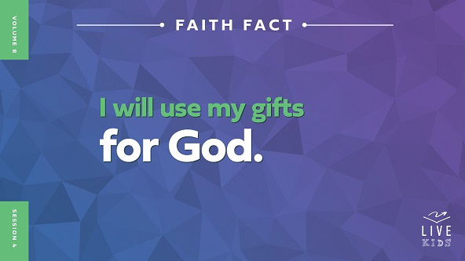

Let’s say the Faith Fact again. When we say it, do an action that represents your favorite talent. For example, if you like to sing, pretend you’re singing into a microphone. If it’s sports, pretend to throw or kick a ball while you say it. Ready? **I will use my gifts for God.** Let’s say it one more time. **I will use my gifts for God.**

**Game**

**Guess the Gift Charades**

|  |
| --- |
| ***You Will Need***   * ***Large Group Game Page*** * *Scissors* * *Small container or bucket*   ***Getting Ready***   * *Print the* ***Large Group Game Page*** *and cut apart into slips.* * *Place the slips into the small container.* |

Are you thankful God gave you gifts? *(Group response)* Me too! Every good thing we have is from God. One kind of gift from Him is a talent, but it’s sometimes called an ability. We still might need to practice or work hard to become great at our talents.

We’ll have some fun playing a game called Guess the Gift Charades. For each round, one person will draw a slip and then act out that gift or talent for the rest of the group to guess. You can’t say anything as you act out what you read on the slip. The first person to guess the gift wins the round and gets to act out the gift for the next round.

• *Choose one kid to draw a slip and act out the first gift.*

• *Keep playing until you run out of gifts to act out or time.*

Raise your hand if something you’re good at was mentioned in the game. *(Group response)* That's okay if it wasn't! God gives a variety of gifts to people. You might even have two or three of the gifts from the game.

**Worship**

Some of you have the gift of singing or playing an instrument while others might not feel like that is their strength. Even if it’s not your best talent, God still loves it when we express our love to Him through worship. Your worship is a gift back to God to show Him you honor and love Him.

• *Lead the kids in singing one or two praise songs. See suggestions at the beginning of the session.*

**Bible Lesson**

God loves to hear us worship Him through singing or playing an instrument. Remember we can worship Him every day through everything we say and do. Let’s pray and invite God to show us how to use our talents, time, and treasures for Him.

**Prayer**

|  |
| --- |
| *Dear God, thank You for the gifts You have given to us. As we read Your Word, help us to learn how to use them to honor You. Amen.* |

**Video Intro**

Just before we look at the Bible story, let’s watch this video.

• *Play* ***Bible Lesson Video****.*

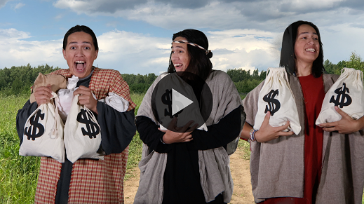

**Bible Story**

**Parable of the Talents**

That video was a great lead-in to our Bible story today! Dash’s grandpa challenged him to use his art talent to bless others. Then, his grandpa told Dash a parable Jesus told people. Jesus often used stories like this to teach about the kingdom of heaven. The people didn’t always know what Jesus meant by these parables, but Jesus would usually share the meanings with His closest disciples.

**Teaching Time**

|  |
| --- |
| ***You Will Need***   * *Small paper lunch bags, fifteen* * *Black marker* * *Large bag, big enough to hold the bags of “money”* * *Crumpled paper* * *Small shovel or gardening trowel*   ***Getting Ready***   * *Use the marker to draw a dollar sign on the outside of each small paper bag.* * *Fill the bags with crumpled paper to expand them.* * *Place the smaller bags in the larger bag.* |

Jesus taught about the kingdom of heaven during His ministry on earth. Think about the kingdom of heaven as a way of saying how things should be with God as king. Jesus shared parables or stories to help people understand how God wants things to be right now and also how things will be in the future. Let’s look more closely at one of Jesus’ parables. Grab your Bible or pull up a Bible app on your device. Turn to [Matthew 25:14*–*30](https://ref.ly/logosref/Bible.Mt25.14-30).

• *In order to keep Large Group time moving along, we recommend that the leader reads the Scripture portions aloud.*

• *Optional: Remind the kids to mark this place with their Bible bookmark so they can read it on their own at home.*

**1. The master trusted his servants with his money.**

• *Show the* ***Teaching Point 1 Slide.***

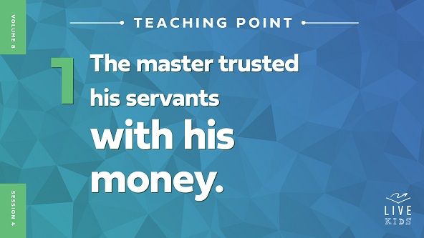

• *Read* [*Matthew 25:14–15*](https://ref.ly/logosref/Bible.Mt25.14-15)*.*

Jesus began His parable by telling about a man who was preparing to leave for a long trip. He had three servants that he told to look after his money. He decided to leave a different amount of money with each of the servants. I need three volunteers to come up and help me illustrate Jesus’ story.

• *Choose three kids and give each kid the number of bags of money as you talk.*

The master gave five bags of money to the first servant, two bags of money to the second servant, and one bag of money to the third servant. How do you think the third servant who only received one bag of money might have felt? *(Allow responses.)* He may have felt disappointed that the master gave the other servants more money than him.

Sometimes we can get distracted by what we don’t have instead of looking at what we do have. It might seem unfair when someone else has more than you. God has given you exactly the gifts you need to accomplish your part of His mission. It’s up to you to make the most of what you’ve been given. Let’s see how the three servants took care of the master’s money.

**2. The master returned and checked in with his servants.**

• *Show the* ***Teaching Point 2 Slide.***

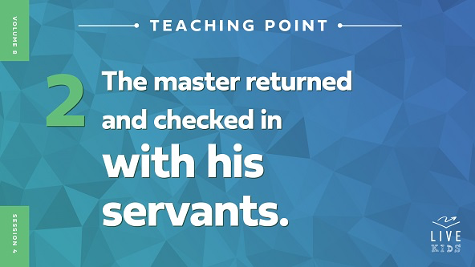

• *Read* [*Matthew 25:16–18*](https://ref.ly/logosref/Bible.Mt25.16-18)*.*

Let’s talk about what those three servants did while the master was gone with the money they had been given. What did the first servant do? *(Allow responses.)* He invested the money and earned five more bags of money. *(Hand the first volunteer five more bags.)* Wow! You have so much money that you can’t even hold it all! The second servant did the same, and he earned two more bags of money. *(Hand the second volunteer two more bags.)* Not bad! Both of the first two servants managed to double the master’s money while he was gone on his trip.

What do you think the master hoped the third servant did? *(Allow responses.)* We might guess that the third servant also invested his one bag of money and increased it. But is that what happened? *(Group response)* No! The third servant dug a hole in the ground.

• *Hand the third volunteer the shovel and pretend to dig a hole in the ground.*

Then, he hid his master’s money. Will money multiply when it’s buried in the ground? *(Group response)* Definitely not. It just sits there unused. The same thing is true with the talent, time, and treasure that God has given to us. Those things only serve God if we use them to help fulfill His mission.

**3. The master reacted to the servants’ choices.**

• *Show the* ***Teaching Point 3 Slide.***

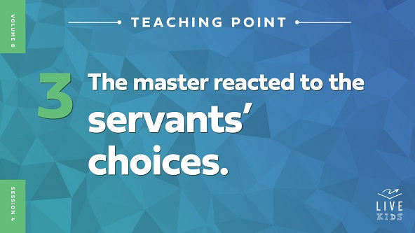

• *Read* [*Matthew 25:19–30*](https://ref.ly/logosref/Bible.Mt25.19-30)*.*

How did the master react to the way his servants had taken care of the money he had given them? Let’s review.

• *Use the big bag to collect the small bags of money from the volunteers as you talk about them.*

The first servant came to the master with ten bags of money, showing that he had doubled the master’s money. *(Collect the bags.)* How did the master respond? *(Group response)* He praised his servant and said, “Well done!”

The second servant came to the master with the four bags of money he now had. *(Collect the four bags.)* The master responded the same way to the second servant. Does that surprise you since he earned less money? *(Allow responses.)* The master was satisfied that the servant took good care of the money.

How did things go for the third servant with one bag of money? *(Allow responses.)* The third servant made excuses about why he chose to do nothing with his master’s money. How did the master respond to him? *(Allow responses.)* He wasn’t happy with the servant because he had wasted the opportunity to use what he had been given. The master didn’t give that man another chance. Instead, the master gave his bag of money to the first servant.

• *Take the one bag of money and hand it to the first kid.*

What does the ending of Jesus’ parable mean? Jesus basically answered that question in verse [29](https://ref.ly/logosref/Bible.Mt25.29). He said that when we use the gifts He has given to us well, we will receive even more. However, if we choose to be like the third servant and do nothing with what we’ve been given, God won’t trust us with anything more.

**Prayer and Response**

*Consider playing a worship song softly in the background while kids pray.*

God has given you gifts. He is watching to see how you use the talents, time, and treasure that He has entrusted to you. If you find ways to put these things into action to further His mission, God will bless you. We shouldn’t do good things because we think God will give us more in return. But, when we use the gifts God has given to us for good, His blessing will naturally come to us. Let’s thank God for the talents, time, and treasure He has given us and ask Him how He wants us to use them. Pray about that quietly on your own. Then, we’ll close in prayer.

• *Encourage kids to remain quiet and focus on praying.*

• *Optional: Ask kids to share what they feel like God said to them.*

**Prayer**

*Optional: Have the kids repeat phrases of the prayer after you.*

|  |
| --- |
| *Dear God, thank You for the unique gifts You have given me. Help me not to allow my gifts to go to waste. Show me how to use them to further Your mission. Help me use them to tell people about You. Amen.* |

**Faith Verse**

Our Faith Verse reminds us to praise God and give glory to His name. Let’s say our Faith Verse and do the actions together.

• *Play* ***Faith Verse Video****.*

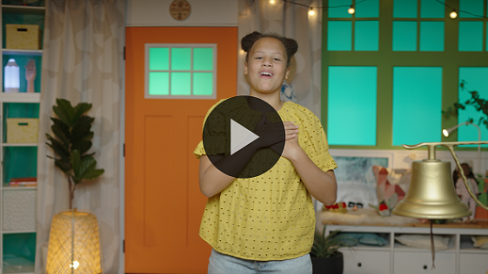

[Psalm 86:12](https://ref.ly/logosref/Bible.Ps86.12) (NLT)

With all my heart I will praise you, O Lord my God. I will give glory to your name forever.

**Faith Fact**

Before we go to our small groups, let’s say our Faith Fact again. **I will use my gifts for God.**

• *Show the* ***Faith Fact Slide****.*



As we say our Faith Fact together one more time, pretend we are unwrapping a gift while we say it. **I will use my gifts for God.** I know we can all find ways to use our gifts for God this week.

• *Dismiss kids to Small Group time or to go home if your group time ends here.*

**Small Group**

**30 Minutes**

*This section can be done in conjunction with the large group or on its own if you do small groups with your kids. During Small Group time, the goal is to connect the kids with the Word of God and to each other. All activities are led by the small group leader.*

**Group Connection**

**Who’s Got Talent?**

God has given all of us gifts. He wants us to use those gifts to honor Him. We learned in our Bible story that wasting the things He’s given by not using them is dishonoring to God. It’s like getting a special gift from someone and never opening it.

I'm giving everyone the chance to share one of your talent gifts right now. I’ll name a category. If you think you have a special talent in that area, raise your hand. When I call on you, tell us about your talent and maybe even show it to us. Let’s see “Who's Got Talent?”

• *Talent categories can include singing, gymnastics, quoting Scripture, physical strength, comedy, connecting with people, and any other categories you would like to add.*

• *Give kids opportunities to share about and show off their talents.*

Wow! You have incredible talents. I shouldn’t be surprised because God created you and gave you these special gifts and skills. Always remember who gave you those talents and why. God wants us to use our talents for Him.

**Bible Lesson Recap**

• *If small group activities are not immediately following large group time, you may want to read the Bible story passage before the discussion.*

|  |
| --- |
| ***You Will Need***   * *Bibles for kids in the group to share*   *No prep needed for this activity.* |

**Bible Story Review: Parable of the Talents** [**Matthew 25:14–30**](https://ref.ly/logosref/Bible.Mt25.14-30)

Jesus was an expert storyteller, and He loved to use stories, called parables, to teach the crowds and His disciples. We can read many of His parables in the Bible. Today’s Bible story is a parable Jesus told to teach us to use our gifts for God and His mission. Jesus knew that He would go back to heaven soon and leave His disciples. He wanted them to continue using their gifts to advance God’s mission when He wasn’t there with them.

Jesus taught them a story about a master with three servants. The master represents God and the servants represent all of us. What did the master leave all three servants to take care of while he was gone? *(Group response)* Did all of them do the same thing with the money? *(Group response)* No, they didn’t. Two of the servants invested the master’s money and doubled it. One of the servants chose to dig a hole in the ground and bury the money. Sadly, he did nothing with the money he was to take care of.

When the master returned home, he saw what all three of the servants had done with the money he had given to them. How did the master respond to them? *(Allow responses.)* The master celebrated with the two servants who used his money wisely. But he was unhappy with the third servant who chose to do nothing with the money. The master even took the third servant’s money and gave it to the servant who had been given five bags of money and taken such good care of it.

• *Give each kid a Bible and read the Bible story together.*

**Group Discussion**

*Feel free to use all or just a few questions as a jumping-off place for good discussion. Questions marked with * are designed for more conversation. Adjust the questions based on the age or maturity of your group. Typically, older kids will be able to dive a little deeper than younger ones.*

**Questions**

Why do you think the master chose to leave his money with three different servants?

How do you think it would have felt to receive only one bag of money when the others received more?

What was different about the way the third servant handled the master's money?

* Do you think you would have been more likely to invest the money or to hide it? Why?

How did the way the servants handled the money affect their master?

Is it easy or difficult for you to use the gifts that God has given to you?

* How can you use one of your gifts to serve God's mission?

**Live It**

**Faith Fact**

Our Faith Fact today is **I will use my gifts for God.** God has given us each of us time, talent, and treasure, and He expects us to use them for Him. We have our gifts for a unique purpose that supports God’s mission to reach people for Him.

**Challenge**

Sometimes it’s hard to figure out exactly what your God-given gifts and talents are. Spend some time this week with an adult who knows you well. Ask that person to tell you what gifts they see in you.

**Prayer**

*Finish group discussion by sharing prayer requests and praise reports. Keep track of your small group’s prayer requests and review them each time you meet.*

• *Have kids share and pray for each other’s prayer requests.*

|  |
| --- |
| *Dear God, help us to use the gifts You have given to us for Your mission. We want to honor You by giving back to You the gifts and resources we have. Amen.* |

**Faith Verse Review**

*No prep needed for this activity.*

Our Faith Verse is about praising God and giving Him the glory. Our Faith Verse is [Psalm 86:12](https://ref.ly/logosref/Bible.Ps86.12). Using our gifts for Him is a way that we can bring honor to Him.

• *Show* ***Faith Verse Video****.*



[Psalm 86:12](https://ref.ly/logosref/Bible.Ps86.12) (NLT)

With all my heart I will praise you, O Lord my God. I will give glory to your name forever.

Let’s say it together a couple of times before we do a fun Faith Verse activity together.

* *Say the verse as a group a couple of times.*

**Faith Verse Fun**

**Faith Verse in Action**

I hope you know the Faith Verse by now because it’s time to put it into action. This is not an activity you can do sitting down, so I need everyone to stand up and spread out. We’ll say the Faith Verse while doing different actions or exercises. Even if you get tired, keep going and keep saying the verse. Are you up for the challenge? *(Group response)*

• *Lead the kids in actions while saying the Faith Verse: jumping jacks, running in place, push-ups, burpees, hopping on one foot, crawling, etc.*

• *If kids have physical limitations, have them do an alternate activity while saying the Faith Verse: snapping their fingers, tapping their feet, waving their hand, etc.*

I’m impressed by your stamina and endurance! You really kept going even if you broke a sweat. It’s a great reminder to continue praising God no matter what you’re doing or how tired you get.

**Activity Page**

**My Gifts and Talents**

|  |
| --- |
| ***You Will Need***   * ***Small Group Activity Page****, one per kid* * *Pencils or pens, one per kid* * *Crayons or markers*   ***Getting Ready***   * *Print copies of the* ***Small Group Activity Page****, one per kid.* |

In our Bible story, we learned that God has given us gifts. On your Activity Page, you’ll see examples of some of the things you might be really good at or enjoy doing. That’s one way to find out what gifts God has given you.

• *Hand out a copy of the* ***Small Group Activity Page****, a pencil, and crayons to each kid.*

First, let’s look at these pictures together. If you think the picture shows something God has made you good at, make a mark in the little box. Remember that in our Bible story, the people didn’t get the same number of gifts. You might have one or two of these pictures checked when we’re done, or you might have several. That’s okay!

• *Read and talk about the pictures.*

Our Faith Fact reminds us of why our gifts matter to God. What does it say? **I will use my gifts for God.** God doesn’t want us to hide our gifts or keep them a secret. He wants us to use them to serve Him. In the space below each picture you checked, write one way you can use this gift for God. Then, we’ll take turns sharing one of the pictures we chose with the group and why we picked it.

• *Let each kid share if they are willing. Affirm each one who shares.*

I’m glad you know that God chose gifts just for you! No two of you were created with exactly the same gifts. God did that because He wants you to serve Him in a way that only you can. I hope that you will use your gifts to show Him and others how much you love Him.

**Dismissal**

Are you thankful for the gifts God has given you? *(Group response)* I think we should celebrate those gifts together before we dismiss. I believe that God would be honored by our celebration. Let’s clap and cheer as loudly as possible to thank God for our gifts. *(Group response)* That was a lot of celebrating, but God deserves it. Let’s pray and thank Him for everything.

**Prayer**

|  |
| --- |
| *Dear God, thank You for creating each of us. We want to use our gifts to serve You. Help us to learn from the parable about the three servants how to honor You with our gifts. We love You! Amen.* |

**Faith Fact Recap**

• *Show the* ***Faith Fact Slide****.*



Many people choose to use their gifts to make their own life better. But, we’re meant to use them for God and His mission. Remember today’s Faith Fact as you go. **I will use my gifts for God.** Thanks for joining me today. See you next time!

• *Send home the* ***Small Group Activity Page.***

• *Remind parents that there are* ***Family Devotions*** *available on the app to do with their kid.*

• *Tell everyone the date and time for the next session.*